[Top 5 courses on Udemy for QA | Automation - Java Selenium | ISTQB | Manual Testing](http://courses.thetestingacademy.com/)

## [**Manual Testing + ISTQB**](http://courses.thetestingacademy.com/)

* **The Complete 2023 Software Testing Bootcamp**
  + <https://www.udemy.com/course/testerbootcamp/>
* **Learn Manual Software Testing + Agile with Jira Tool**
  + <https://www.udemy.com/course/learn-manual-software-testing-with-live-project-jira-tool/>
* ISTQB
  + **Certified Tester ISTQB® Foundation Level (CTFL) Updated 2022**
  + <https://www.udemy.com/course/certified-tester-foundation-level-ctfl/>
* **ISTQB Foundation Level Complete Training**
* <https://www.udemy.com/course/foundation-level-training/>

## [**API Testing & Automation**](http://courses.thetestingacademy.com/)

* Postman
  + Postman: The Complete Guide - REST API Testing
  + <https://www.udemy.com/course/postman-the-complete-guide/>
* 42 Postman Videos + FREE videos
  + <https://www.youtube.com/watch?v=e6otrkQNaCA&list=PL8VbCbavWfeEvyUo5qCEw96LNjPR5rR2k>

* Rest Assured
  + Rest API Testing (Automation) from Scratch-Rest Assured Java
  + <https://www.udemy.com/course/rest-api-automation-testing-rest-assured/>

## [**Web Automation + Cucumber BDD**](http://courses.thetestingacademy.com/)

* <https://www.udemy.com/course/selenium-automation-architect-tutorials/>
* <https://www.udemy.com/course/cucumber-bdd-selenium-java-complete-automation-course/>
* <https://courses.thetestingacademy.com/>
  + 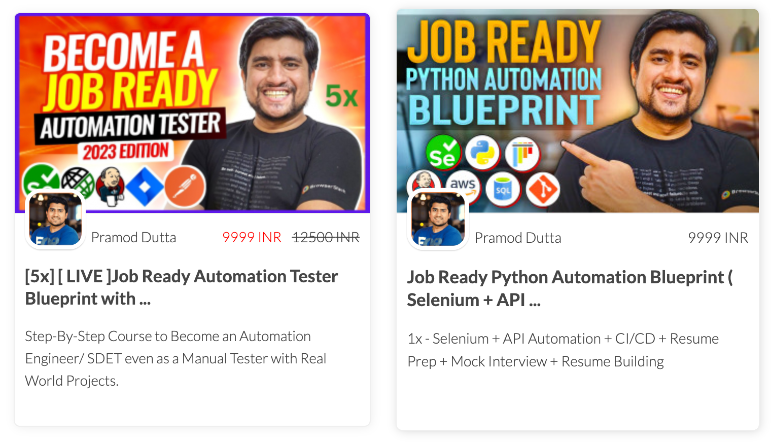

## [**Performance Testing**](http://courses.thetestingacademy.com/)

* JMeter
  + <https://www.udemy.com/course/learn-jmeter-from-scratch-performance-load-testing-tool/>
  + <https://www.udemy.com/course/learn-jmeter-m/>
* Raghav - <https://www.youtube.com/watch?v=SoW2pBak1_Q>

## [Security Testing](http://courses.thetestingacademy.com/)

## Learn Ethical Hacking From Scratch

## <https://www.udemy.com/course/learn-ethical-hacking-from-scratch/>

## 

## [Core Java](http://courses.thetestingacademy.com/)

* Masterclass: Start Coding in 2023

<https://www.udemy.com/course/java-the-complete-java-developer-course/>

## 

## JIRA

* <https://sdet.live/agile>
* Git
* <https://sdet.live/git>

**Amazon Web Services (AWS) - Zero to Hero ( FREE)**

<https://www.udemy.com/course/amazon-web-services-aws-v/>